Name :Khush Pithva 24BCE174
Subject : Data Structure (2CS501)
Practical no.: 1A
AIM : Write a C program to maintain a record of n students details using an array of structures with four fields (roll no, name, marks, and grade). Assume the appropriate data type for each field. Print the marks of the student given the student’s name as input.

INPUT :
#include<stdio.h>
#include<string.h>
struct student
{
int roll;
char name[10];
float marks;
char grade[2];
};
int main()
{
struct student std[5];
for(int i=0;i<5;i++)
{
printf("-------FOR STUDENT %d-------\n",i + 1);
printf("enter the roll no. of student:\n");
scanf("%d",&std[i].roll);
printf("enter the name of student:\n");
scanf("%s",&std[i].name);
printf("enter the marks of student:\n");
scanf("%f",&std[i].marks);
printf("enter the grade of student:\n");
scanf("%s",&std[i].grade);
}
for(int j=0;j<5;j++)
{
printf("-------FOR STUDENT %d-------\n",j + 1);
printf("roll no. of the student is: %d \n",std[j].roll);
printf("name of the student is: %s \n",std[j].name);
printf("marks of the student is: %f \n",std[j].marks);
printf("grade of the student is: %s \n\n\n",std[j].grade);
}
char username[10];
printf("enter the name of the student you want to find:");
scanf("%s",&username);
for (int x=0;x<5;x++)
{
if(strcmp(std[x].name,username)==0)
{
printf("roll no. of the student is: %d \n",std[x].roll);
printf("name of the student is: %s \n",std[x].name);
printf("marks of the student is: %f \n",std[x].marks);
printf("grade of the student is: %s \n",std[x].grade);
}
}
return 0;
}

OUTPUT :
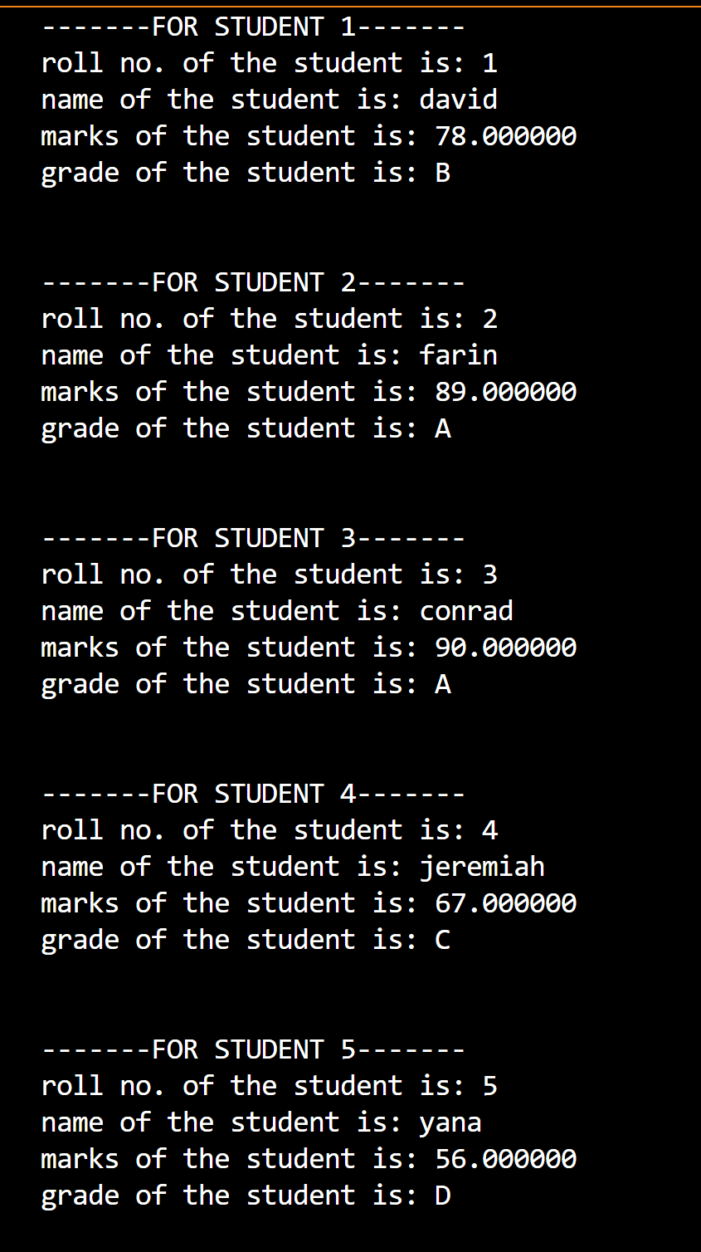
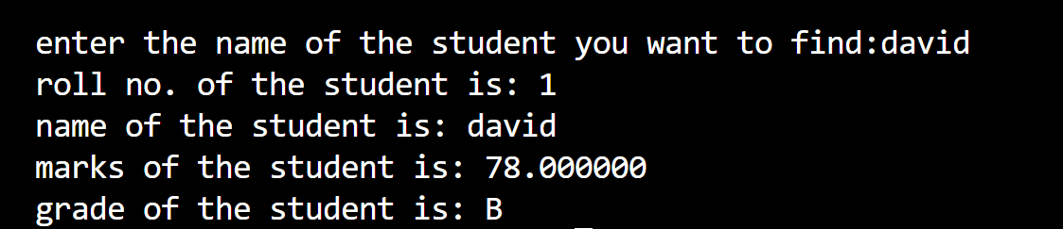

Practical no.: 1B
AIM : Design anagram game using array. Allow a user to enter N words and store it in an array. Generate a random number between 0 to N-1. Based on the random number generated display the word stored at that index of an array and allow user to enter its anagram. Check whether the word entered by the user is an anagram of the displayed number or not and display an appropriate message.

INPUT :
#include<bits/stdc++.h>
using namespace std;

bool anagram(string s1,string s2)
{
if(s1.length()!=s2.length()) return false;

transform(s1.begin(), s1.end(), s1.begin(), ::tolower);
transform(s2.begin(), s2.end(), s2.begin(), ::tolower);
sort(s1.begin(), s1.end());
sort(s2.begin(), s2.end());

return s1 == s2;
}

int main()
{
int n;
cin>>n;
string words[n];

for (int i = 0; i < n; i++) {
cout << "Word " << i + 1 << ": ";
cin >> words[i];
}
srand(time(0));
int random = rand() % n;

string selected = words[random];
cout << "\nYour word is: " << selected << endl;

string usrword;
cout << "Enter the anagram of the above word: ";
cin >> usrword;
cout<<endl;

if (anagram(selected, usrword))

cout << "Correct! '" << endl << usrword << "' is an anagram of '" << selected << "'." << endl;
else
cout << "Wrong! '" << endl << usrword << "' is NOT an anagram of '" << selected << "'." << endl;

return 0;
}
OUTPUT :

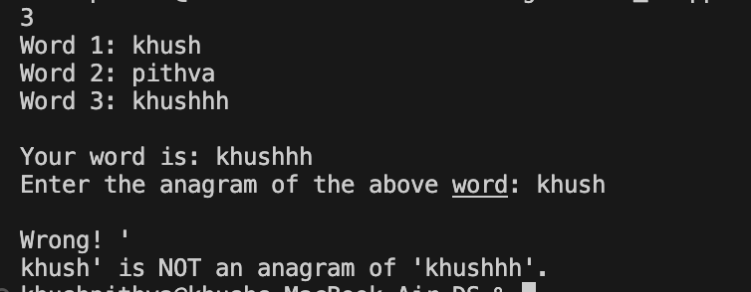

LEETCODE
- Two Sum

INPUT :
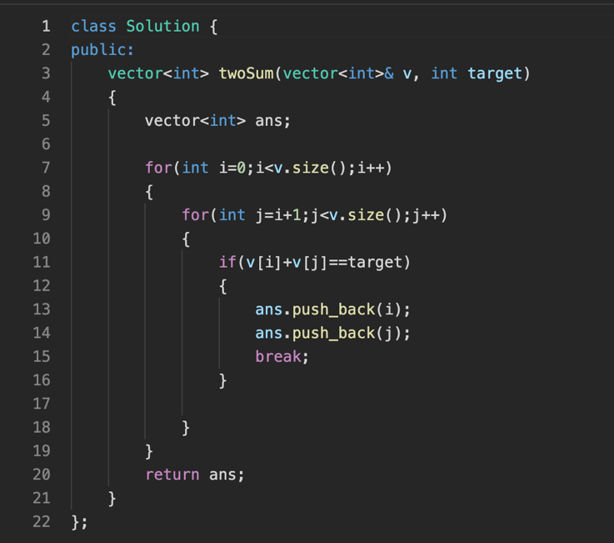
OUTPUT :
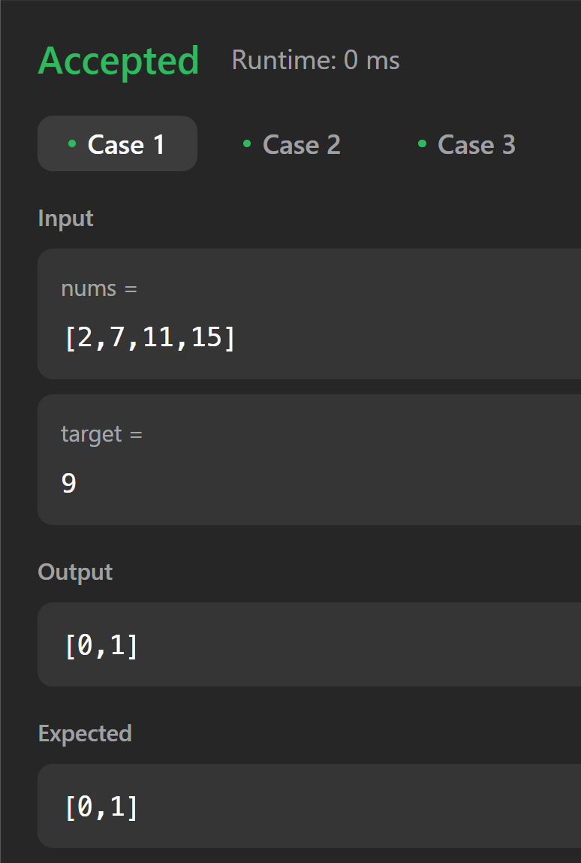

- Best Time To Buy And Sell The Stock

INPUT:
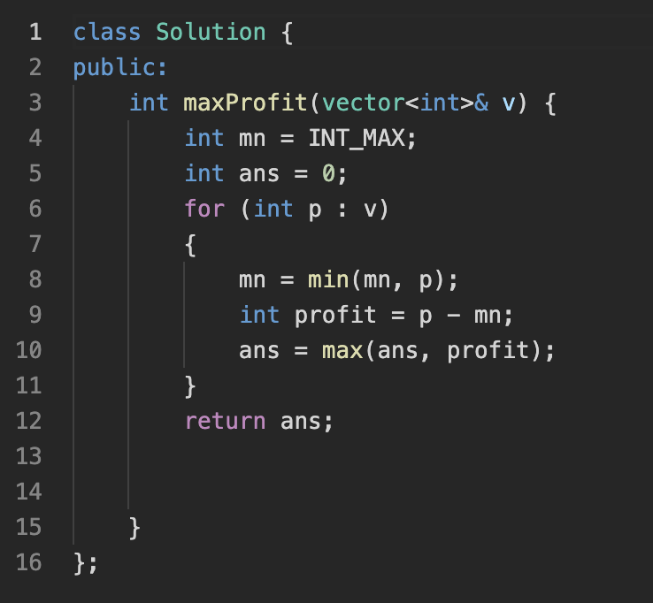
OUTPUT:
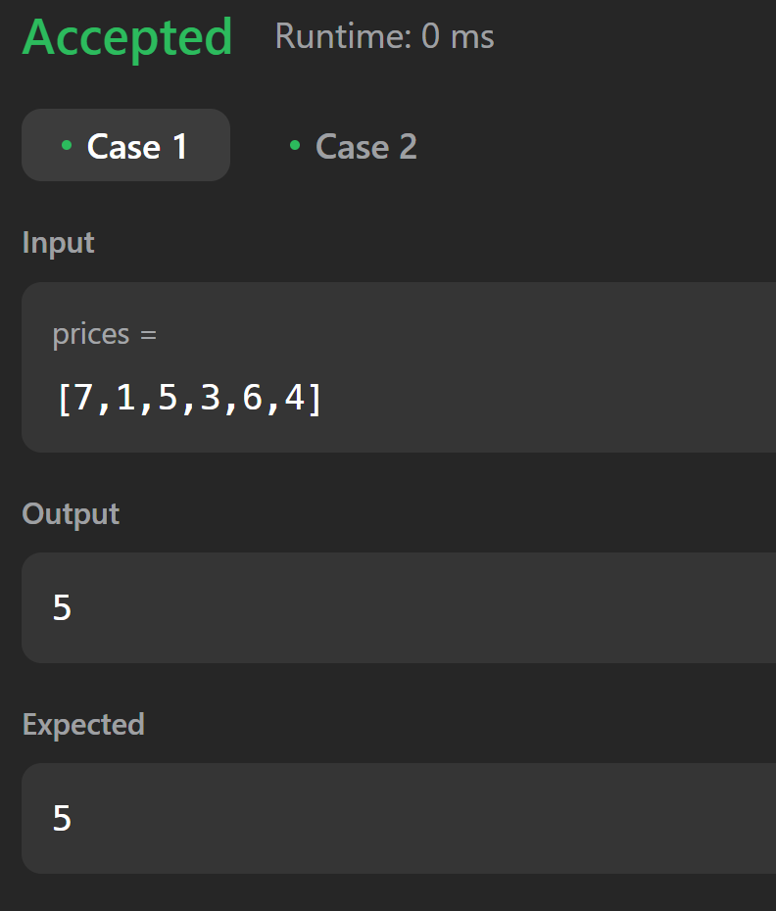

- Maximum Subarray
INPUT:
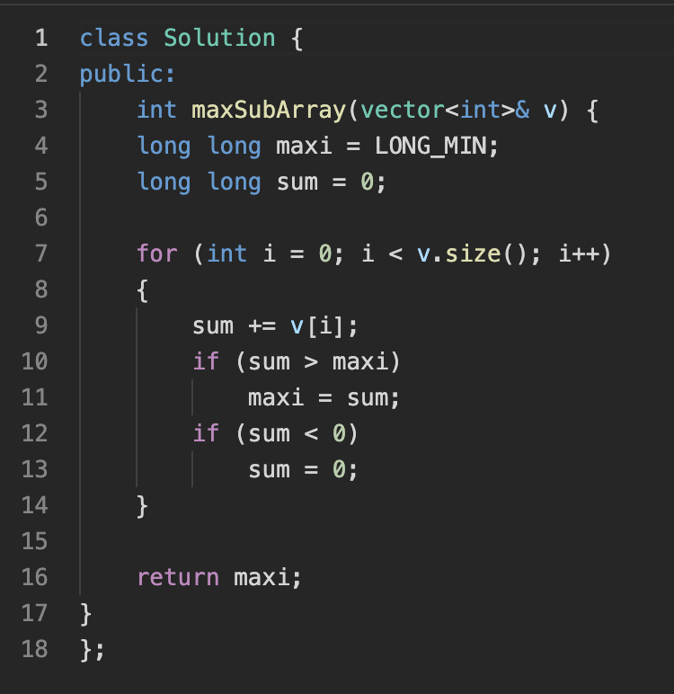
OUTPUT:
